SYSADD1/SYSADD2

2nd TERM, AY 2017-2018

Bonifacio Global City (BGC) Bus Passenger Information System:

Bus Tap

Submitted to:

MS. RHEA-LUZ VALBUENA

MR. MANUEL SEBASTIAN SANCHEZ

Submitted by:

ALCARAZ, ANNA LYNN C.

ANGOT, SAMMY BOY M.

BESMANO, JUSTIN V.

BRIOSO, JOB G.

Submitted on:

NOVEMBER 6, 2017

Table of Contents

Introduction 1

Project Context 1

Purpose and Description 1

Objectives 10

Scope and Limitations 10

Related Literature 10

BGC Bus 10

beep™ card 14

Existing Apps Related to Bus Tap 17

Bus Management System 20

Technical Background 21

Android 21

Database: Android Database SQLite 22

GPS 23

RFID 23

NFC 24

Design and Methodology 25

Requirements Analysis 25

Requirements Documentation 25

Gap Analysis/Needs Assessment 25

Design of Software, Systems, Product, and/or Processes 26

Software Requirements Specifications 26

Functional Description Diagram 27

Use Case Diagram 28

Full Use Case Description 29

Event Table 30

Data Flow Diagram 31

Entity Relationship Diagram 32

Data Dictionary 33

Object Diagram 34

Class Diagram 35

Activity Diagram 36

References 37

Appendix 38

Letter of Request for Interview to the management of the BGC Bus 38

Questions for the Interview with the management of the BGC Bus 39

Interview Transcript 40

Survey Questionnaire 44

Other results of the survey conducted by the group on BGC Bus passengers 46

List of Tables

Table 1. Results of the survey conducted by the group on BGC Bus passengers: What are the problems you encounter when riding the BGC Bus? 2

Table 2. Results of the survey conducted by the group on BGC Bus passengers: How many minutes do you usually have to wait before boarding the bus? 5

Table 3. Bus Tap vs. Moovit, sakay.ph, and TripBarker. 9

Table 4. Routes and Schedules of the BGC Bus. 11

List of Figures

Figure 1. Problems encountered by the passengers when riding the BGC Bus 3

Figure 2. Results of the survey conducted by the group on BGC Bus passengers: 3

Figure 3. Results of the survey conducted by the group on BGC Bus passengers: 4

Figure 4. Images inside the bus in varying ranges of passenger congestion. 5

Figure 5. Results of the survey conducted by the group on BGC Bus passengers: 6

Figure 6. Images of the queue of passengers waiting for the bus. 7

Figure 7. Results of the survey conducted by the group on BGC Bus passengers: 8

Figure 8. Results of the survey conducted by the group on BGC Bus passengers: 8

Figure 9. Stored value beep™ card (left) and discounted beep™ card (right) 14

Figure 10. How to buy the beep™ card 15

Figure 11. How to use the beep™ card 16

Figure 12. How to reload the beep™ card 17

Figure 13. Homepage of Moovit (https://www.moovitapp.com/) 17

Figure 14. Homepage of sakay.ph (https://sakay.ph/) 18

Figure 15. Homepage of TripBarker (http://www.tripbarker.com/) 18

Figure 16. Query results from Moovit 19

Figure 17. Query results from sakay.ph 19

Figure 18. Query results from TripBarker 19

Figure 19. BMS information collection and provision process 21

Figure 20. World Shipment of NFC-enabled Cellular Handsets 24

Figure 21. Results of the survey conducted by the group on BGC Bus passengers: 46

Figure 22. Results of the survey conducted by the group on BGC Bus passengers: 46

Figure 23. Results of the survey conducted by the group on BGC Bus passengers: 46

# Introduction

## Project Context

The Bus Tap is both a web-based application and a mobile-based application that will provide commuters with information regarding the Bonifacio Global City (BGC) Bus. It will provide a map indicating all the routes and stops of the BGC Bus, and several points of interests around BGC. The app will also provide detailed itineraries to the user from an origin to a destination they input in the app, indicating the closest bus stop, available bus routes, fare, and estimated travel time. The application will also display the operating schedule of the different bus routes of the BGC Bus, and the arrival and departure times of every bus at every bus stop. It will also display the real-time location of the buses. For each bus stop, it will display the number of minutes until the next bus arrives. Because most of the passengers of the BGC Bus use their beep™ cards to pay for the bus fare, users will also be able to check the remaining balance on the beep™ cards using the app. Should the users need to load the beep™ cards, the application will also be able to display the locations of the nearest beep™ card loading stations.

## Purpose and Description

Bonifacio Global City (BGC) is one of Manila’s Central Business Districts. Companies, especially business process outsourcing (BPO) firms, have made BGC the base of their operations in the country. With its strategic location near EDSA (Epifanio de los Santos Avenue), C-5, and SLEX (South Luzon Expressway), BGC is accessible from all points of the Metro.

To travel from, to, and within BGC, though some people rely on private vehicles, the majority relies on mass transport, mostly, the BGC Bus. The BGC bus caters to 44,000 passengers daily on weekdays, and 20,000 passengers daily on weekends (Obias, 2017). The BGC Bus has 12 routes to help commuters navigate their way around BGC: North, North Express, East Express, Upper West Express, Lower West Express, Central, Night, East, West, Ayala Express, ARCA South Express, and Nuvali Express.

Among those who travel to BGC, there are some who are not familiar to navigating around BGC. Various apps, like sakay.ph, TripBarker, and Moovit, have been made available to help commuters navigate through Metro Manila using mass transit. These apps provide their users with detailed itineraries to navigate from an origin to a destination, indicating the modes of transportation to use, route, estimated travel time, and fare. Though these apps are useful to commuters, these apps lack other features that BGC Bus passengers may find useful to help ease their travel and to minimize their waiting time.

The group conducted a survey amongst 60 passengers of the BGC Bus (refer to Appendix for the Survey Questionnaire). The passengers were asked about problems encountered when riding the BGC Bus (e.g. long queue when buying bus ticket or loading beep™ card, long queue when waiting for the bus, inaccurate bus schedules, congestion of passengers inside the bus). Table 1 and Figures 2 and 3 show the results of the survey about the problems passengers encounter when riding the BGC Bus.

Table 1. Problems encountered by the passengers when riding the BGC Bus

|  |  |  |
| --- | --- | --- |
| Problems encountered when riding the BGC Bus | Passengers who encountered  the problem | Percentage (%) out of 60 passengers |
| long queue when buying bus ticket or loading beep™ card | 5 | 8% |
| long queue when waiting for the bus | 45 | 75% |
| inaccurate bus schedules | 35 | 58% |
| congestion of passengers inside the bus | 15 | 25% |

Figure 1. Problems encountered by the passengers when riding the BGC Bus

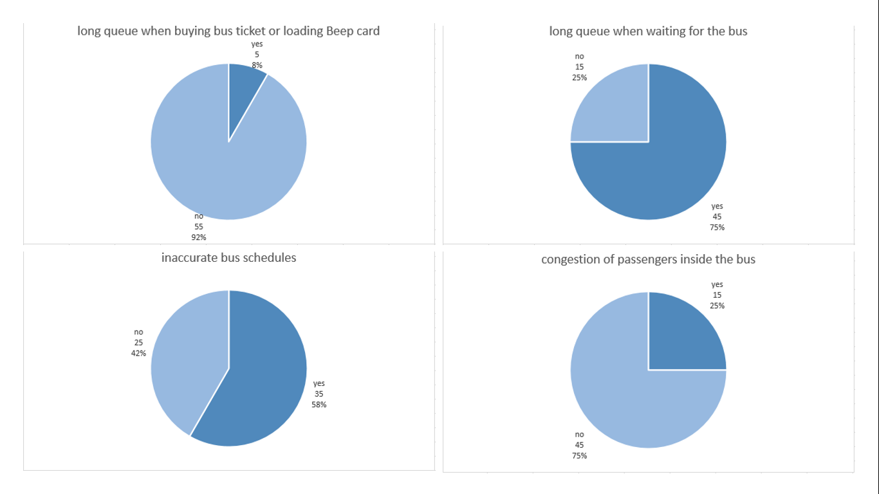

Figure 2. Results of the survey conducted by the group on BGC Bus passengers:

percentage of correspondents that encountered problems regarding

the long queue when buying bus ticket or loading beep™ card (upper left),

long queue when waiting for the bus (upper right),

inaccurate bus schedules (lower left), and

congestion of passengers inside the bus (lower right)

From the results of the survey, most of the passengers do not encounter problems regarding long queue when buying bus ticket or loading their beep™ card. Most of the passengers only take 1-2 minutes to buy ticket or load their beep™ cards at the teller booths. Figure 3 shows show the results of the survey about the time passengers take to buy ticket or load beep™ cards.

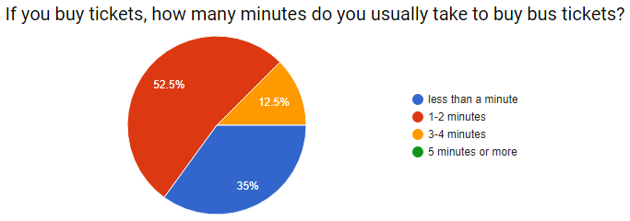

Figure 3. Results of the survey conducted by the group on BGC Bus passengers:

How many minutes do you usually take to buy ticket or load your beep™ card?

From the results of the survey, most of the passengers also do not encounter problems regarding congestion of passengers inside the bus. Buses of the BGC Bus can accommodate 75 passengers, having a seating capacity of 37 passengers and can accommodate additional 38 standing passengers (Obias, 2017). Figure 4 shows images inside the bus in varying ranges of passenger congestion.

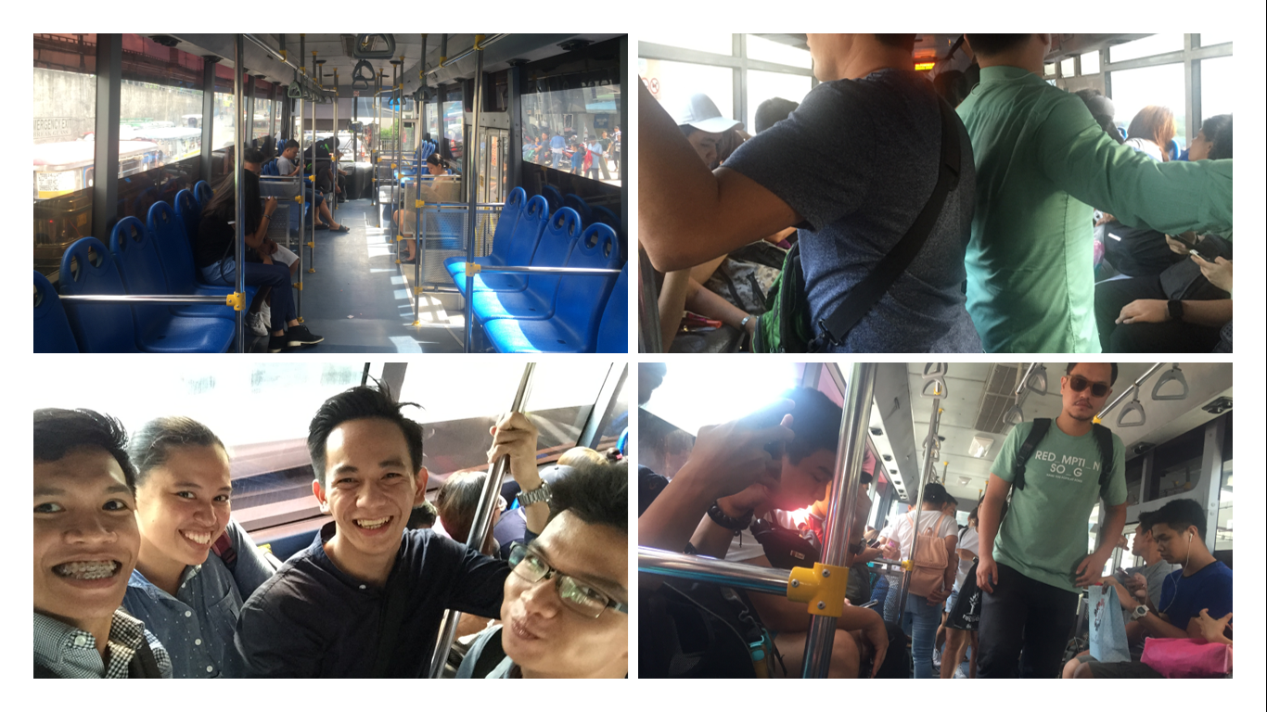

Figure 4. Images inside the bus in varying ranges of passenger congestion.

Images taken by members of the group.

The passengers were also asked about the average number of minutes they usually wait for the BGC Bus. Table 2 and Figure 5 show the results of the survey about the average waiting time of the passengers for the BGC Bus.

Table 2. Results of the survey conducted by the group on BGC Bus passengers: How many minutes do you usually have to wait before boarding the bus?

|  |  |
| --- | --- |
| Average waiting time  before boarding the BGC Bus | Number of passengers |
| 1-5 minutes | 6 |
| 6-10 minutes | 5 |
| 11-15 minutes | 24 |
| 16-20 minutes | 15 |
| 21-25 minutes | 0 |
| 25-30 minutes | 5 |
| more than 30 minutes | 5 |

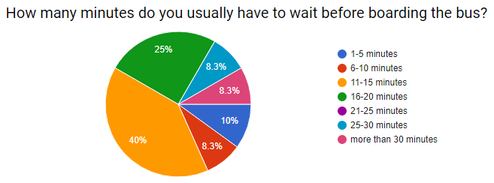

Figure 5. Results of the survey conducted by the group on BGC Bus passengers:

How many minutes do you usually have to wait before boarding the bus?

In an interview conducted by the group with the management of the BGC Bus, the company’s goal was to keep the waiting time of passengers to a maximum of ten minutes (refer to Appendix for the Interview Transcript). From the survey conducted by the group, more than half of the passengers of the BGC Bus have encountered problems regarding the long queue when waiting for the bus, with 40% having to wait for 11-15 minutes, 25% having to wait for 16-20 minutes, 8% having to wait for 25-30 minutes, and another 8% having to wait for more than 30 minutes. Out of 60 BGC Bus passengers surveyed, 81% or 49 passengers answered having to wait for the bus for longer than 10 minutes. Figure 6 shows images of the queue of passengers waiting for the bus.

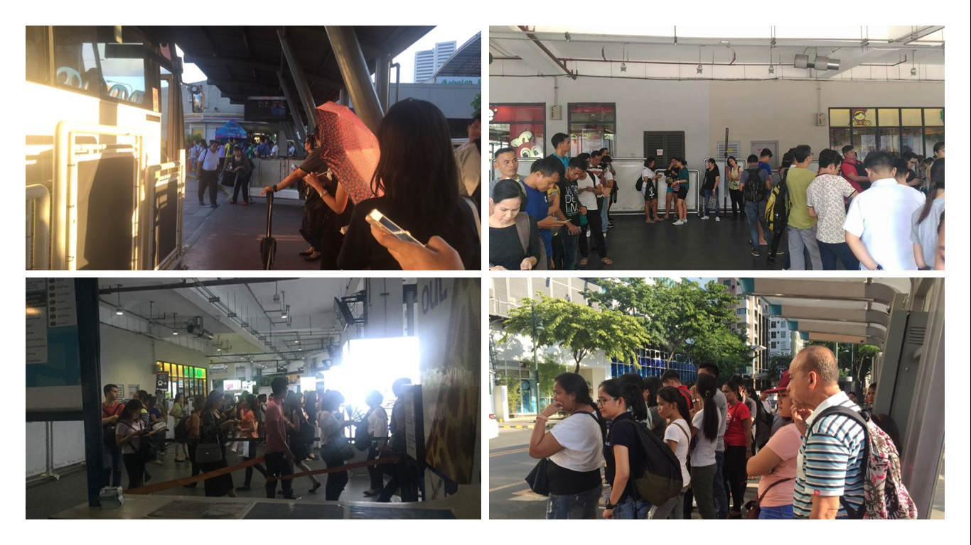

Figure 6. Images of the queue of passengers waiting for the bus.

Images taken by members of the group

The Bus Tap aims to prevent or minimize the problems encountered by the passengers of the BGC Bus. With information regarding bus arrival times and departure times, real-time bus status, and congestion status, passengers can decide when best to take the bus, minimizing the amount of time spent waiting for the bus. With the seat reservation feature of the app, users of the app can also reserve seats on the BGC Bus ahead of time.

BGC Bus passengers were asked if an app for the BGC Bus would be useful. Fifty passengers or 83% answered that the passengers of the BGC Bus would find an app useful. Figure 7 shows the results of the survey on whether passengers will find an app for the BGC Bus useful.

Figure 7. Results of the survey conducted by the group on BGC Bus passengers:

Will an app be useful to you?

The passengers were also asked about the features of a BGC Bus app that would be useful. Figure 8 shows the results of the survey on features of an app for the BGC Bus the passengers will find useful.

Figure 8. Results of the survey conducted by the group on BGC Bus passengers:

What features of a BGC Bus app will be useful to you?

Most of the passengers find the proposed features of a BGC Bus app useful. Because of this, the Bus Tap aims to provide the passengers of the BGC Bus with all the necessary information they need. With information regarding the status of bus operations and operating schedule, passengers can decide whether to take the bus, or to take an alternative mode of transportation. With information regarding bus arrival times and departure times, real-time bus status, and congestion status, along with the feature of congestion prediction, passengers can decide when best to take the bus. With the seat reservation feature, passengers are ensured of a seat inside the bus. With the added feature of allowing passengers to check the remaining balance on their beep™ cards, passengers no longer need to go to the nearest loading stations to check. The app also displays the nearest beep™ card loading stations should the passenger need to load the beep™ cards. Table 3 shows the comparison of the Bus Tap app to other existing transit apps:

Table 3. Bus Tap vs. Moovit, sakay.ph, and TripBarker.

|  |  |  |  |  |
| --- | --- | --- | --- | --- |
| Features | Moovit | sakay.ph | TripBarker | Bus Tap |
| Web-based | ✔ | ✔ | ✔ | ✔ |
| Mobile-based | ✔ | ✔ | ✔ | ✔ |
| Commuting routes | ✔ | ✔ | ✔ | ✔ |
| Arrival and departure times | ✖ | ✖ | ✖ | ✔ |
| Minutes-to-arrival | ✖ | ✖ | ✖ | ✔ |
| Bus locator | ✖ | ✖ | ✖ | ✔ |
| Congestion status  and prediction | ✖ | ✖ | ✖ | ✔ |
| Checking of remaining  beep™ card balance | ✖ | ✖ | ✖ | ✔ |

## Objectives

The Bus Tap aims to be able to:

* provide relevant information regarding the BGC Bus;
* decrease the waiting time of passengers riding the BGC Bus to 10 minutes; and
* help users navigate their way around Bonifacio Global City using the BGC Bus.

## Scope and Limitations

The Bus Tap will be available both as a web-based application and a mobile-based application; however, the app will only be available to Android devices, because most of the NFC-enabled devices are Android devices. The app will also be limited to the BGC Bus. As such, locations that will be included in the app will be limited to within BGC and some areas of Makati, Taguig, and Sta. Rosa, Laguna.

# Related Literature

## BGC Bus

The BGC Bus has a fleet composed of 51 buses with seating capacity of 37 passengers, but can fit a total of 75 passengers (Obias, 2017). These buses are deployed to 12 routes to help commuters navigate their way around BGC: North, North Express, East Express, Upper West Express, Lower West Express, Central, Night, East, West, Ayala Express, ARCA South Express, and Nuvali Express.

The North Route, North Express Route, East Express Route, Upper West Express Route, Lower West Express Route, Central Route, Night Route, East Route, and West Route only travel within BGC. The North Route operates from Mondays to Fridays only, from 6:30AM to 10:00AM and from 4:30PM to 8:30 PM. The North Express Route, East Express Route, Upper West Express Route, and Lower West Express Route also operates from Mondays to Fridays only, but from 6:00AM to 10:00PM. The Central Route operates every day from 6:00AM to 10:00PM, while the Night Route also operates every day from 10:00PM to 6:00AM. The West Route and the East Route operate on Saturdays, Sundays, and holidays, from 6:00AM to 10:00PM.

The extension routes, Ayala Express Route, Arca South Express Route, and Nuvali Express Route travel to Makati City, Taguig City, and Sta. Rosa, Laguna, respectively. These routes operate from Mondays to Fridays only during peak hours. Peak hours of the BGC Bus are from 6:00AM to 10:00AM and from 4:00PM to 10:00PM (Obias, 2017). The Arca South Express Route operates from 6:10AM to 9:00AM and from 4:00PM to 8:00PM. The Ayala Express Route operates only on mornings from 7:00AM to 10:00AM. The Nuvali Express Route only has one morning trip at 6:30AM, and two evening trips at 6:30PM and 7:15PM. Table 4 shows the routes and schedules of the BGC Bus:

Table 4. Routes and Schedules of the BGC Bus.

|  |  |  |  |
| --- | --- | --- | --- |
| Routes | Day | Time | Stops |
| Central | Everyday | 6:00AM to 10:00PM | Market! Market!  One Parkade  RCBC  Net One  Bonifacio Stopover  Crescent Park West  HSBC  The Globe Tower  Nutriasia  University Parkway |

|  |  |  |  |
| --- | --- | --- | --- |
| Night | Everyday | 10:00PM to 6:00 AM | EDSA Ayala  McKinley Parkway  RCBC  Net One  Bonifacio Stopover  Crescent Park West  HSBC  The Globe Tower  Nutriasia  University Parkway  Market! Market!  One Parkade  RCBC  Net One  Bonifacio Stopover  Crescent Park West  Fort Victoria |
| North | Weekdays | 6:30AM to 10:00AM and  4:30PM to 8:30 PM | North Station  Uptown Park Suites  Park Triangle  BGC Turf  The Globe Tower  RCBC  Net One  Bonifacio Stopover  Crescent Park West  Nutriasia  Uptown Mall  Uptown Parade |
| North Express | Weekdays | 6:00AM to 10:00PM | Edsa Ayala  HSBC  The Globe Tower  Nutriasia  BGC Turf |
| East Express | Weekdays | 6:00AM to 10:00PM | EDSA Ayala  Market! Market! |
| Upper West Express | Weekdays | 6:00AM to 10:00PM | EDSA Ayala  Bonifacio Stopover  Crescent Park West |
| Lower West Express | Weekdays | 6:00AM to 10:00PM | EDSA Ayala  RCBC  Net One  Fort Victoria |
| East | Weekends | 6:00AM to 10:00PM | EDSA Ayala  HSBC  The Globe Tower  Nutriasia  University Parkway  Market! Market! |
| West | Weekends | 6:00AM to 10:00PM | EDSA Ayala  McKinley Parkway  RCBC  Net One  Bonifacio Stopover  Crescent Park West  Fort Victoria |
| Ayala Express | Weekdays | 7:00AM to 10:00AM | EDSA Ayala  Ritz Tower  MSE  PBCOM  RCBC Plaza  The Columns  City Gate  Security Bank  SGV Building  Glorietta 5 |

|  |  |  |  |
| --- | --- | --- | --- |
| Arca South Express | Weekdays | 6:10AM to 9:00AM and  4:00PM to 8:00PM | Arca South  Market! Market!  RCBC  Net One  Bonifacio Stopover  Crescent Park West  Nutriasia  Market! Market! |
| Nuvali Express | Weekdays | 6:30AM, 6:30PM,  and 7:15PM | Nuvali  Market! Market! |

Fare for each trip is Php 12.00 for all routes, except for Arca South Express Route and Nuvali Express Route; fare for the Arca South Express Route is Php 24.00. Tickets are not sold on board a BGC Bus. When taking the BGC Bus, passengers can either buy single-journey tickets or pay using their tap-and-go beep™ cards. Tickets are sold at cashier counters at BGC Bus terminals (e.g. Ayala, Market! Market!, and Bonifacio One Technology Tower) or from ticket sellers at selected bus stops (e.g. Bonifacio Stopover, RCBC, and Nutriasia).

## beep™ card

The beep™ card is a stored value contactless smart card issued by AF Payments Inc (AF Payments, Inc., 2016). Three types of beep™ cards are available: single journey, stored value, and discounted cards. Figure 9 shows the stored value beep™ card and discounted beep™ card.

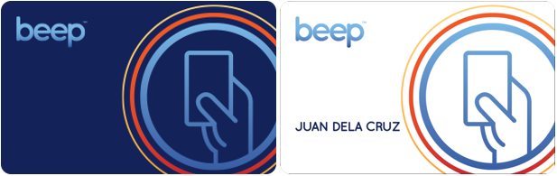

Figure 9. Stored value beep™ card (left) and discounted beep™ card (right)

<https://www.beeptopay.com/home.html>

Single journey cards are single-use beep™ cards with values ranging from Php 13.00 to Php 30.00. These cards can be bought at the teller booths in any of the stations of the LRT-1, LRT-2, and MRT-3.

Stored value cards are multiple-use beep™ cards, and can be bought for Php 20.00 in the train stations, or Php 50.00 at other beep™ card loading stations, valid for four years from the date of first purchase. Minimum amount for reloading stored value cards is Php 20.00. Stored value cards have a load limit of Php 10,000.00. Figure 10 shows how to buy a stored value beep™ card from a ticket vending machine.

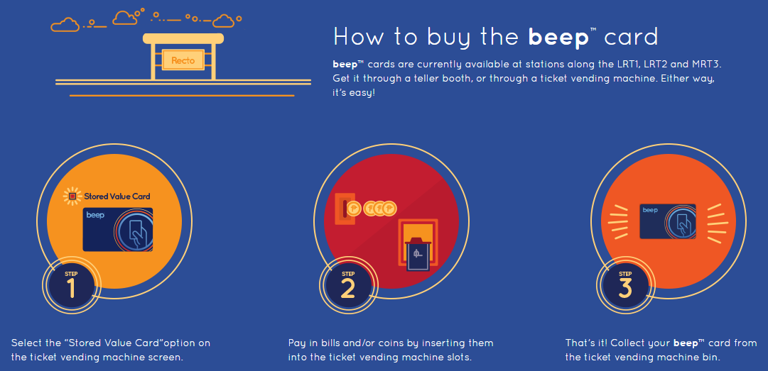

Figure 10. How to buy the beep™ card

<https://www.beeptopay.com/home.html>

Discounted cards are stored value cards for senior citizens, persons with disability (PWD), and for students. Senior citizens, persons with disability (PWD), and for students, upon presenting their ID, can register for a discounted beep™ card at any LRT1, LRT2, and MRT3 station to avail of fare discounts. Application form for the discounted beep™ card can be downloaded on their official website.

beep™ cards are most often used as cashless payment on the LRT1, LRT2, in the MRT3. Several bus companies (e.g. Froehlich Tours, HM Transport, RRCG Transport, Citylink Coach Services, BGC Bus, and TAS Trans Inc.) also accept payment through the beep™ cards (AF Payments, 2016). beep™ cards can also be used in lieu of cash in some convenience stores (e.g. FamilyMart and Circle K) (AF Payments, 2016). Figure 11 shows how to pay using the beep™ card.

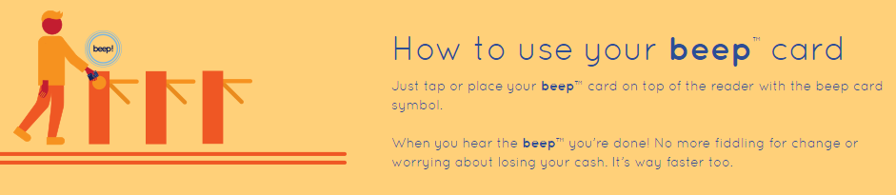

Figure 11. How to use the beep™ card

<https://www.beeptopay.com/home.html>

beep™ cards can be loaded at the ticket vending machines or at teller booths in any of the stations of the LRT-1, LRT-2, and MRT-3. Figure 12 shows how to reload beep™ cards at the ticket vending machine. beep™ cards can also be loaded at all FamilyMart branches and Circle K branches in BGC, or at select Bayad Center, Tambunting, Villarica and SM Bills Payment Counters (AF Payments, 2016). Commuters can also load their beep™ cards at the following bus terminals:

* HM Transport: Baclaran and NAIA T3,
* BGC Bus: EDSA, Market! Market!, and Bonifacio One Technology Tower,
* CityLink: McKinley, San Lorenzo Place, Eastwood, and Newport,
* Froehlich: Glorietta 5 and Trinoma, and
* RRCG: Alabang Town Center, Greenbelt 1, Greenbelt 5, Star Mall Alabang, and Star Mall Shaw.

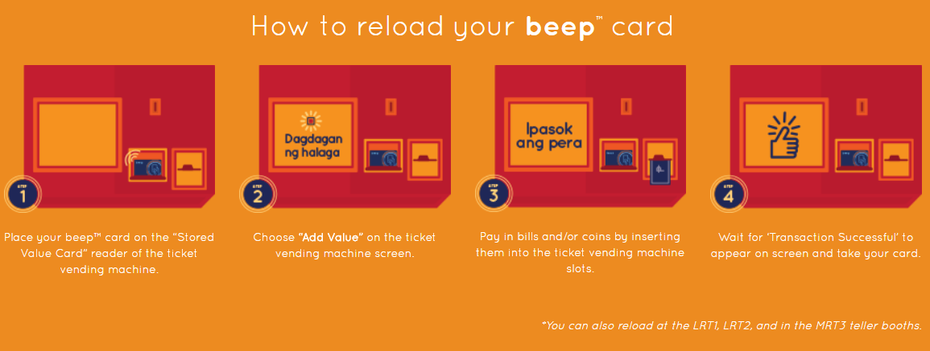

Figure 12. How to reload the beep™ card

<https://www.beeptopay.com/home.html>

## Existing Apps Related to Bus Tap

Various apps, like Moovit (https://www.moovitapp.com/), sakay.ph (https://sakay.ph/), and TripBarker (http://www.tripbarker.com/) are already available to help commuters navigate through Metro Manila using mass transit. These apps provide their users with detailed itineraries to navigate from an origin to a destination, indicating the modes of transportation to use, route, estimated travel time, and fare. Figures 13 to 15 shows the homepage of Moovit, sakay.ph, and TripBarker.

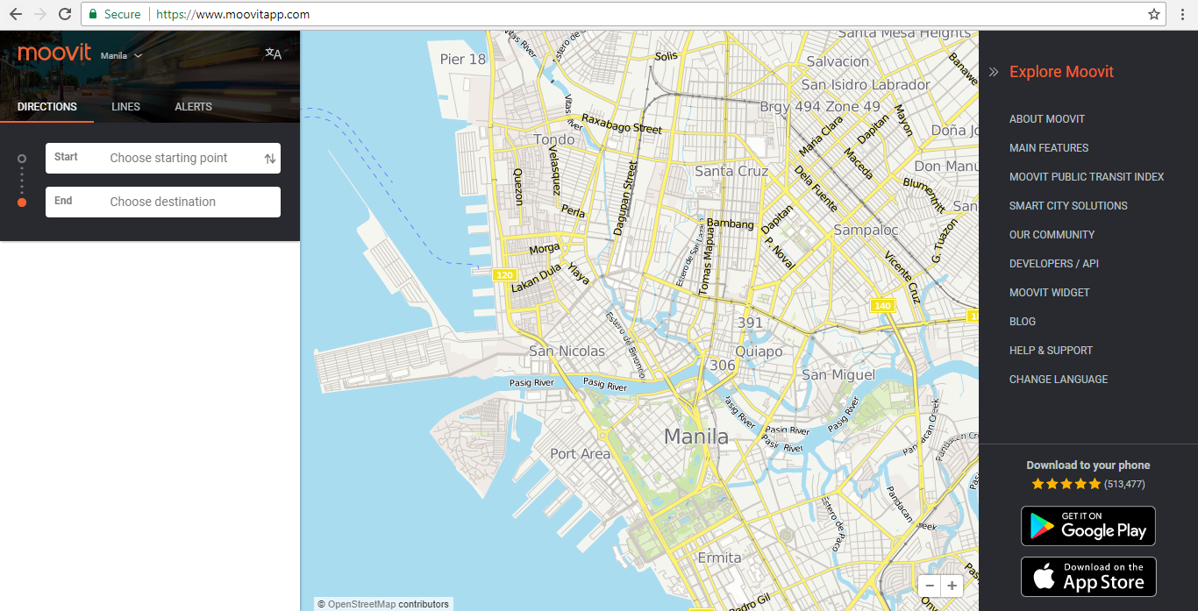

Figure 13. Homepage of Moovit (https://www.moovitapp.com/)

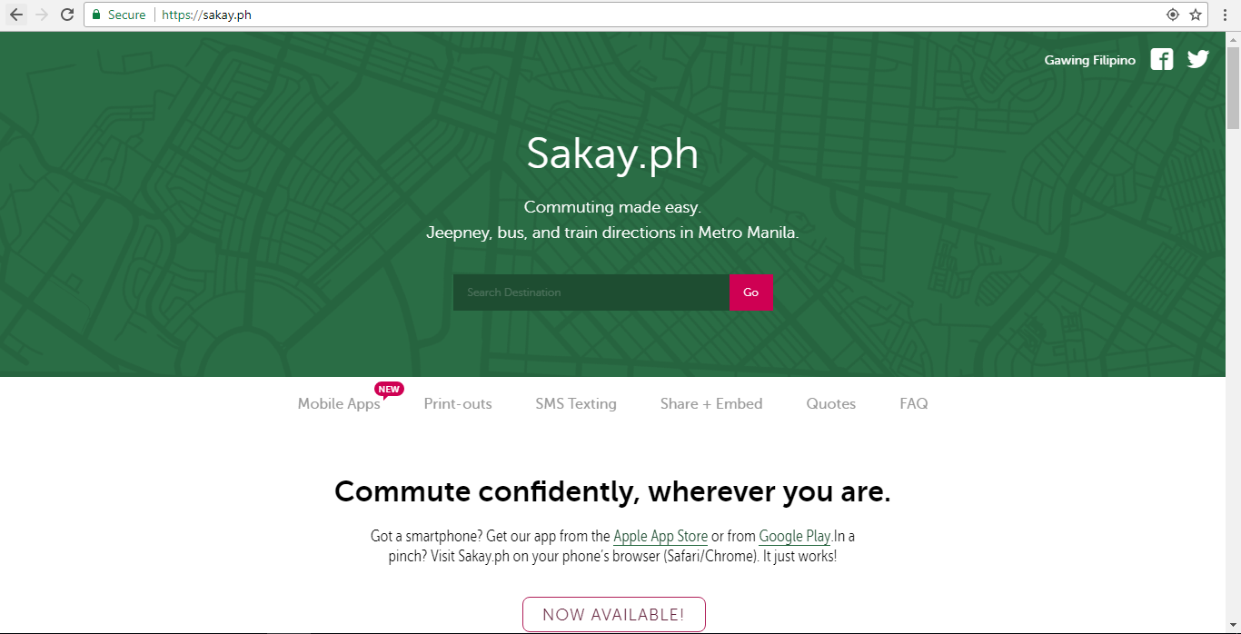

Figure 14. Homepage of sakay.ph (https://sakay.ph/)

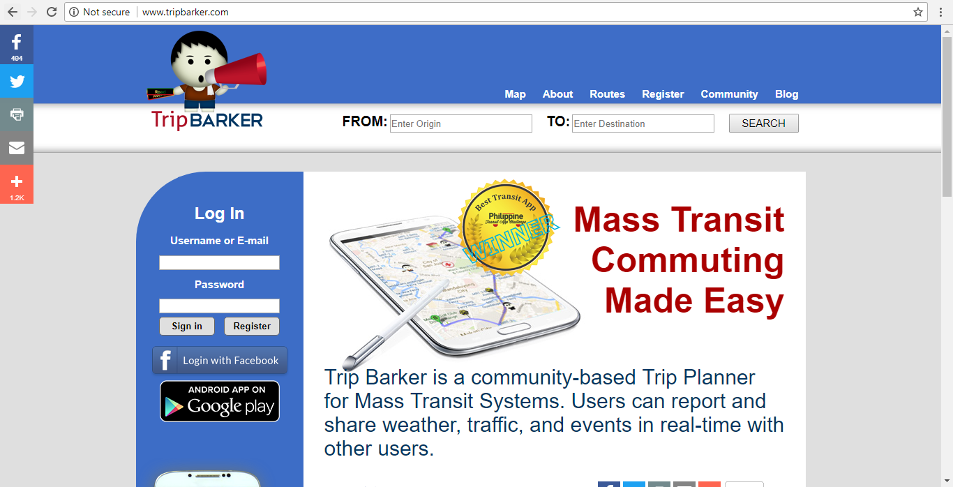

Figure 15. Homepage of TripBarker (http://www.tripbarker.com/)

These apps may be able to give detailed itineraries to their users; however, because of the wide range of locations these apps cover, results for within BGC do not show the most optimal way. When these apps were tested using MRT Ayala station as the place of origin and Market! Market! as the place of destination, the apps did not show the BGC Bus as a feasible mode of transportation. Commuters can ride the East Express Route of the BGC Bus to go directly from the BGC Bus Ayala terminal to the BGC Bus Market! Market! terminal. Figures 16 to 18 show the query results from Moovit, sakay.ph, and TripBarker.

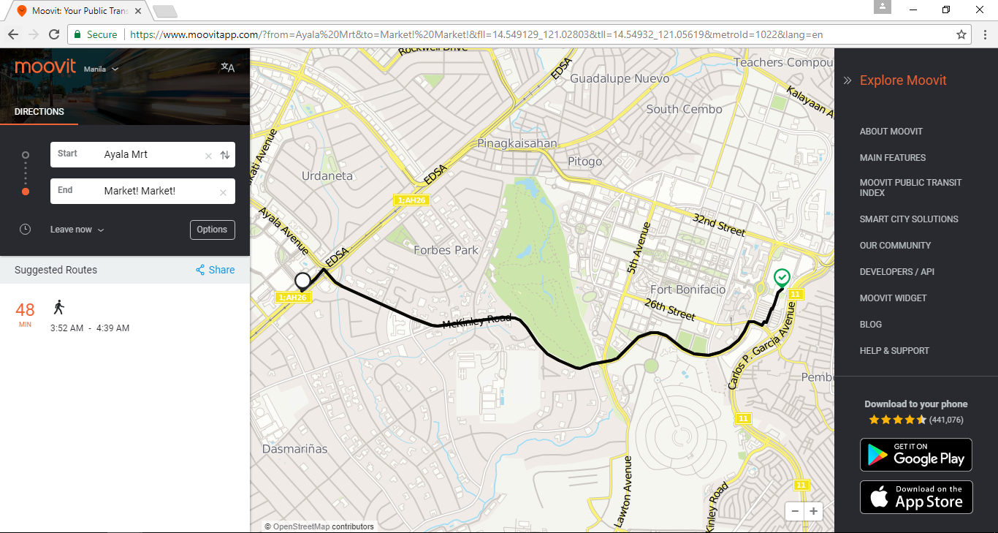

Figure 16. Query results from Moovit

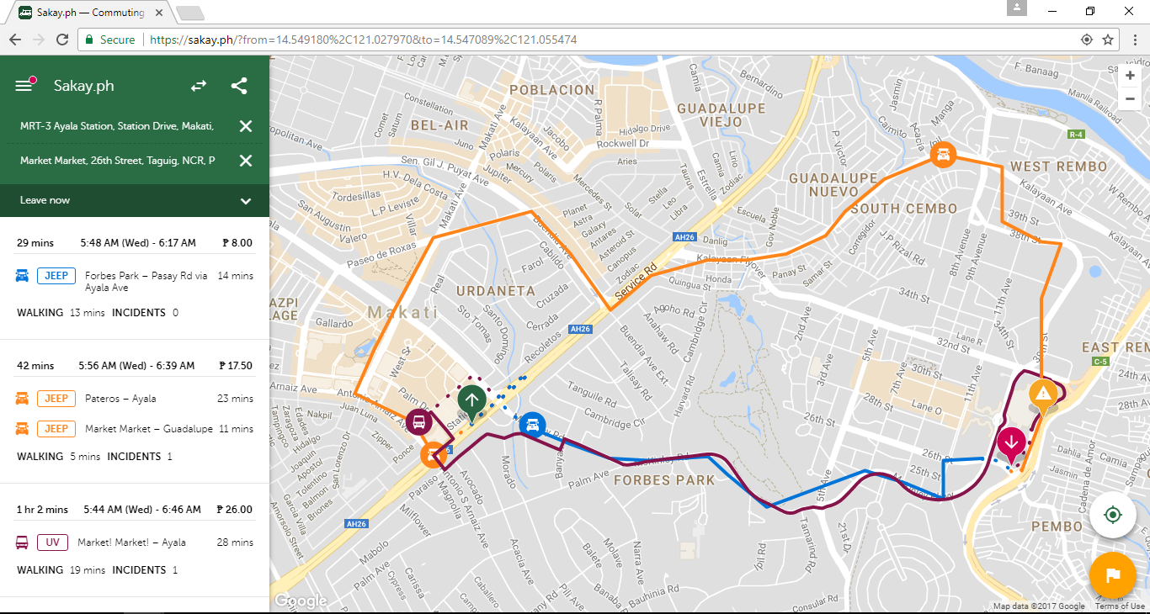

Figure 17. Query results from sakay.ph

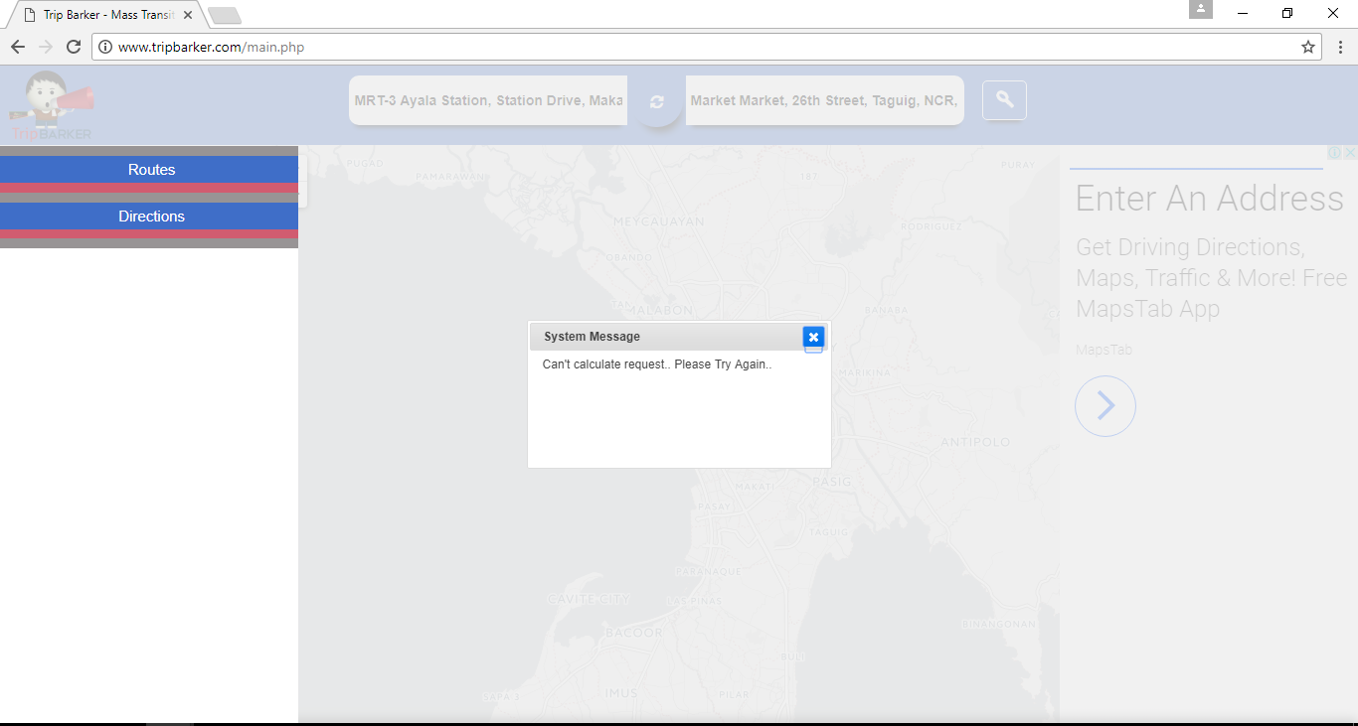

Figure 18. Query results from TripBarker

These apps also lack other features that commuters may find useful for their travels, to help ease their travel, and to minimize their waiting time.

## Bus Management System

Bus Management System (BMS) is an integrated information on buses. The BMS is aimed to improve the degree of satisfaction with services for the passengers based on punctuality of buses and to generate basic data required to establish public transport policies in the future. It has developed into a system that can offer diversified benefits to passengers, bus drivers, and bus operators.

From the perspectives of the passengers, provision of information on bus operation minimized waiting time and expected time of arrival. And it gave them very detailed information of arrival for their easy access to bus.

As bus drivers received operational information including interval, distances between the buses, they were able to adjust their driving speed which led to establishing improved operational order and punctuality.

From the perspectives of bus operators, the number of passengers increased by enhancing control over speeding and irregular interval, and led to a reduction in accidents. In particular, corporate control over illegal operations such as skipping bus stops contributed to improving bus services.

As for system configuration for the purpose of establishing BMS, it consists of information collection system, information processing system and information provision system. The information collection system includes processing GPS location information in a bus OBU (On Board Unit) based on bus operation routes and transmitting 20-second regular data and event data to an information center via wireless data communication network at a time of departure and arrival at stops. The information processing system established a database on collected information through communication servers and location processing servers. The information provision system offers information to drivers, bus companies, the public and city government based on provision of information to the public and bus companies through linked servers. Figure 19 shows the BMS information collection and provision process.

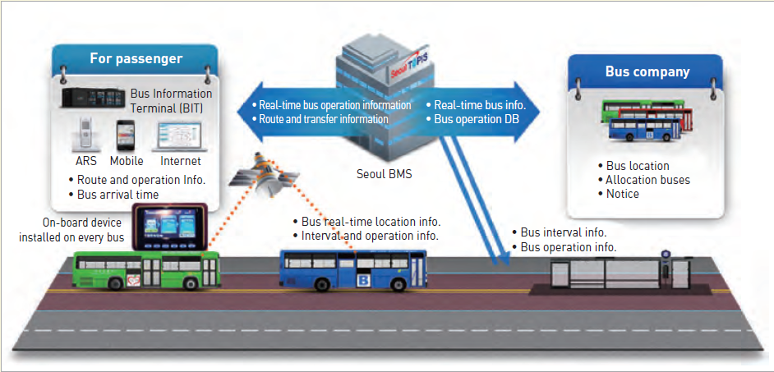

Figure 19. BMS information collection and provision process

# Technical Background

## Android

Android operating system is one of the most common operating system that is being used in the market. This type of OS can be found and most compatible on our modern devices, being smartphones the most popular. Although it can also be found and used on Smart TVs, tablets, Smart Watches, computers, and other portable gadgets.

Android OS is a system software that manages every hardware and software running resources. The primary work of Android OS is to provide services to its host computer. It controls all application running in the gadget. Moreover, according to recombu.com, it gives access to apps especially on application made by Google. Because of Android OS, mobile users can play games, check the weather, check the user’s current location, play music, etc. This type of OS has its advantages over other operating system since it is easy to customize.

Again per to recombu.com, it is made customizable so that the phone settings would perfectly fit the taste of the user. The user can change the wallpaper, themes and launchers, unlike some operating system like IOS which make the default system private. Furthermore, a ton of application is more compatible on android compared to others.

## Database: Android Database SQLite

Technically, a database is a collection of related data that is used to process different kinds of information upon the request of the user. It can be accessed with the help of a DBMS (Database Management System) that enables users to interact and have an access to a stored data. By accessing the required data, users can do different function that they want. Although access may be limited sometimes because of security conditions, users may somehow be able to get the information that they want. This makes database important in every application especially on those which has processes that needs to be accessed immediately.

And for android devices, SQLite suits the best data container. SQLite, per sqlite.org, is a library that implements a self-contain and server less database engine. The good thing is that it is open for usage. The code is being shared publicly so that mobile developers can use it on different purposes. And this type of database engine is said to be the most widely spread and most deployed database in the world.

## GPS

The Global Positioning System or GPS is a navigation system that provides necessary information. It usually estimates the time and location of a specific matter on earth. It was developed by the US military and they allow the public to use it for further development and for future use.

Using Global Positioning System is common nowadays as a tool for searching direction when travelling. Users can get accurate directions for travel just by utilizing the use of this technology. Moreover, it can track a specific object. Keeping track on a object is necessary, especially when running a business.

## RFID

RFID stands for Radio-Frequency Identification. A technology that vastly improve through generations. It said to be created during the world war II to transmit, receive and process necessary information. It was named IFF (Identify Friend or Foe System) back then. Basically, RFID at today’s modern society works the same way as IFF.

RFID is naturally built with antenna and a small chip. Moreover, it works with an RFID tag, a readable and writeable device that has a chip, memory and an antenna. Usage of RFIDs requires to have a host for controlling the functions of this technology. It serves as a tool that allows the communication of RFID and RFID tags, furthermore it allows processes like saving data and transmission of signals.

This technology is recommendable to businesses and other transaction processes since it has modern advantages over some common technologies in the market like: RFID does not need direct contact unlike some technologies. Another advantage of using RFID is that objects does not need to be positioned precisely. It can scan even though the object that RFID is scanning does not have a good position. Different from technologies like the barcode scanner where the barcode’s position needs to be perfectly positioned in front of the machine’s scanner.

The improvement in technology specifically by the RFID system serves as an inspiration to other technology creators to create a system using the concept of RFID. And this might be one of the primary inspiration why NFC (Near Field Communication) is made.

## NFC

NFC or Near Field Communication. This type of technology is somehow using the concept of RFID. That made some people said that NFC is a subset of RFID technology. NFC works with smart mobile phones. The processes of this technology allow a phone to interact and communicate with another device wirelessly. Per androidpit.com, it can operate within a radius of having 4 centimeters. The good thing about this technology is that, it does not require any data like wi-fi, mobile data and the internet for it to work

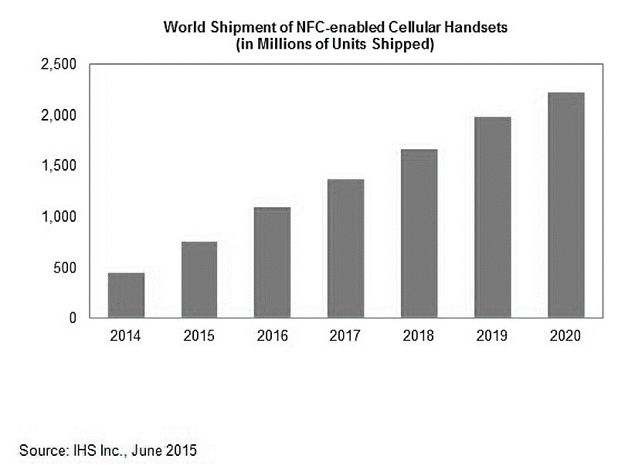

Figure 20. World Shipment of NFC-enabled Cellular Handsets

According to IHS Inc, last june 2015, they were able to release a data that forecasts the shipment of NFC-enabled cellular phones. The graph in table 1 shows how it gradually increse every year. This data proves that NFC-enable mobile phones are being big timely demanded. And according to the researchers, as years goes by, this statistic will continue to arise.

Basically, it is one reason why the proponents of the study decided to use NFC. The technology is being used mostly as of now, so by making an application, mobile users can amximize the usage of NFC on every smart phones.

# Design and Methodology

## Requirements Analysis

## Requirements Documentation

## Gap Analysis/Needs Assessment

## Design of Software, Systems, Product, and/or Processes

### Software Requirements Specifications

### Functional Description Diagram

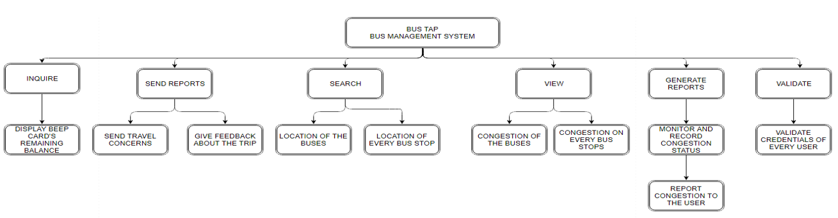

### Use Case Diagram

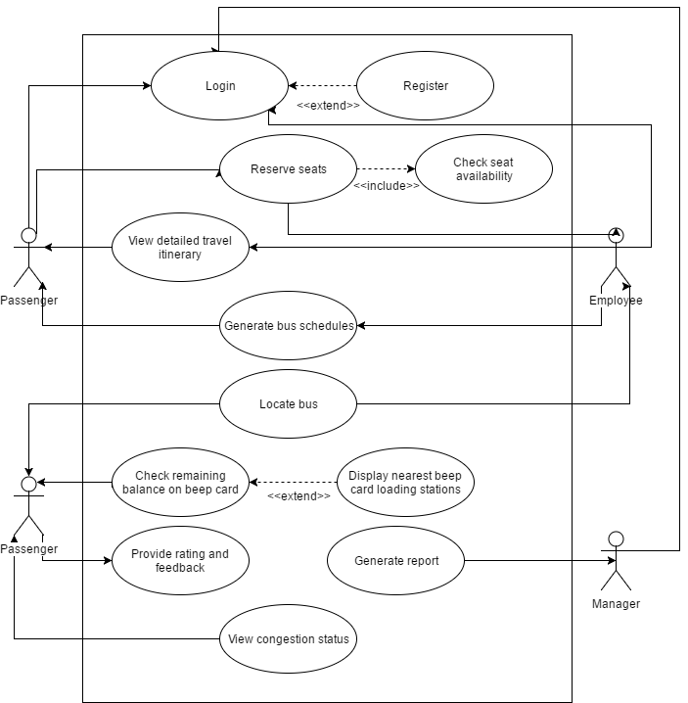

### Full Use Case Description

### Event Table

### Data Flow Diagram

Context Diagram

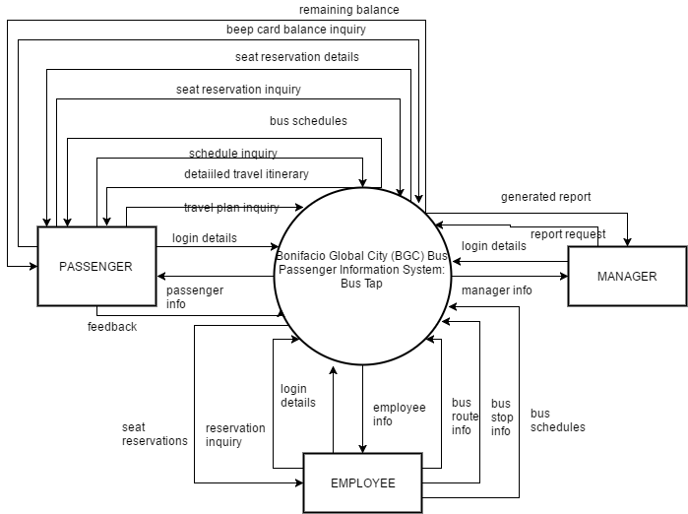

Level 1

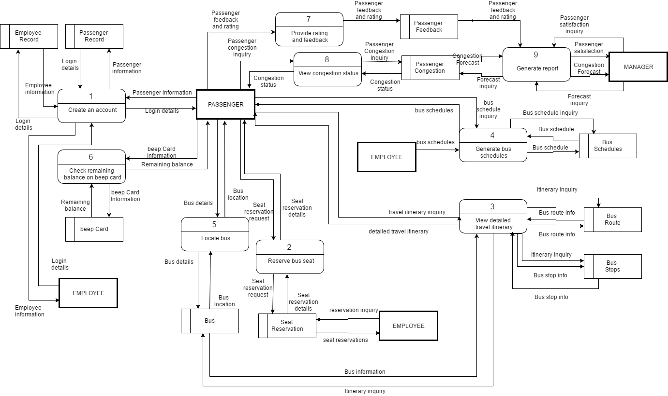

### Entity Relationship Diagram

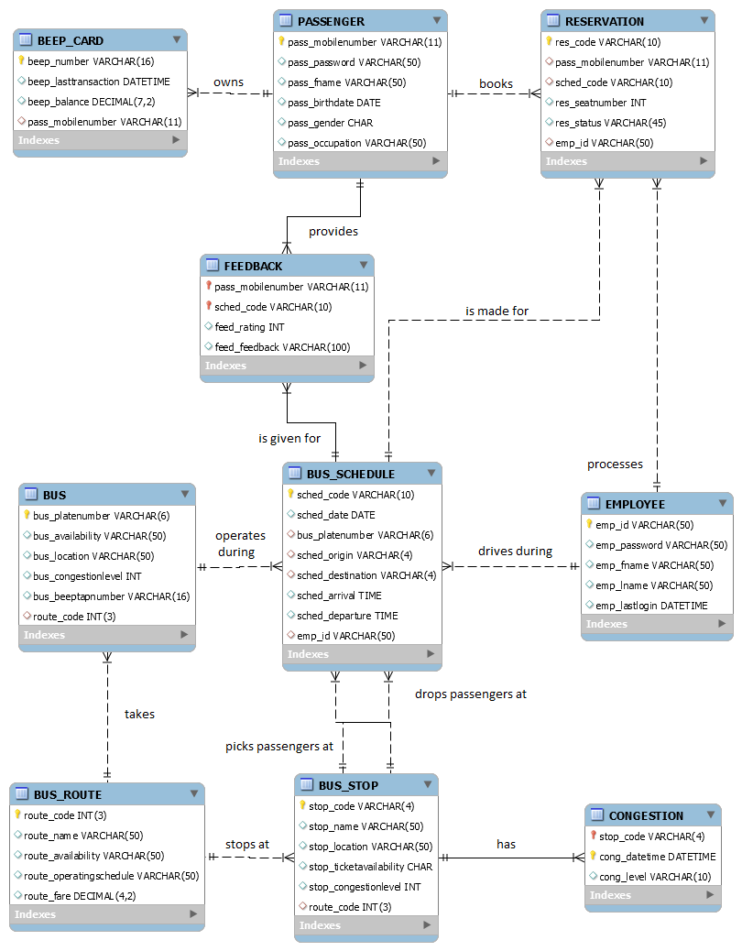

### Data Dictionary

### Object Diagram

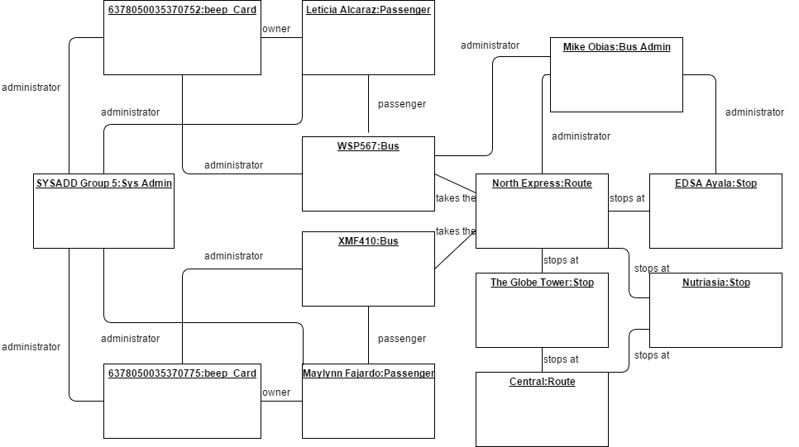

### Class Diagram

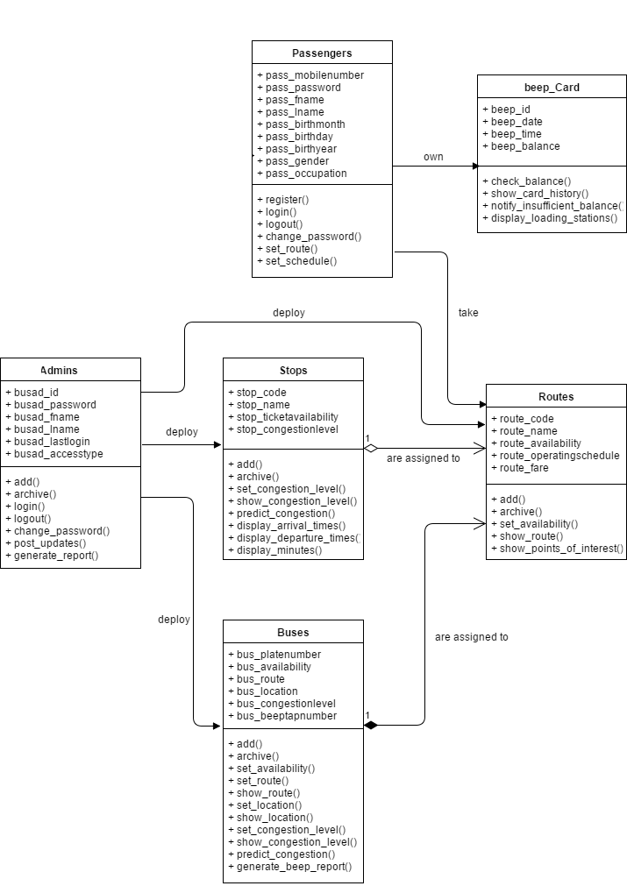

### Activity Diagram

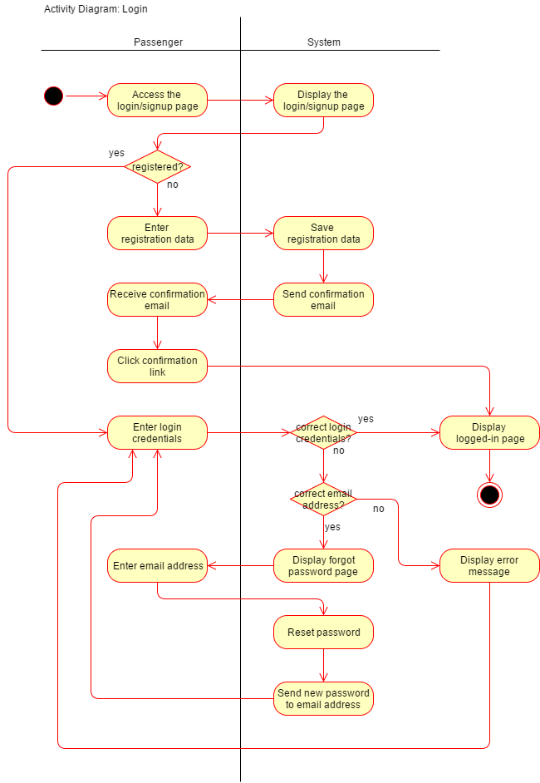

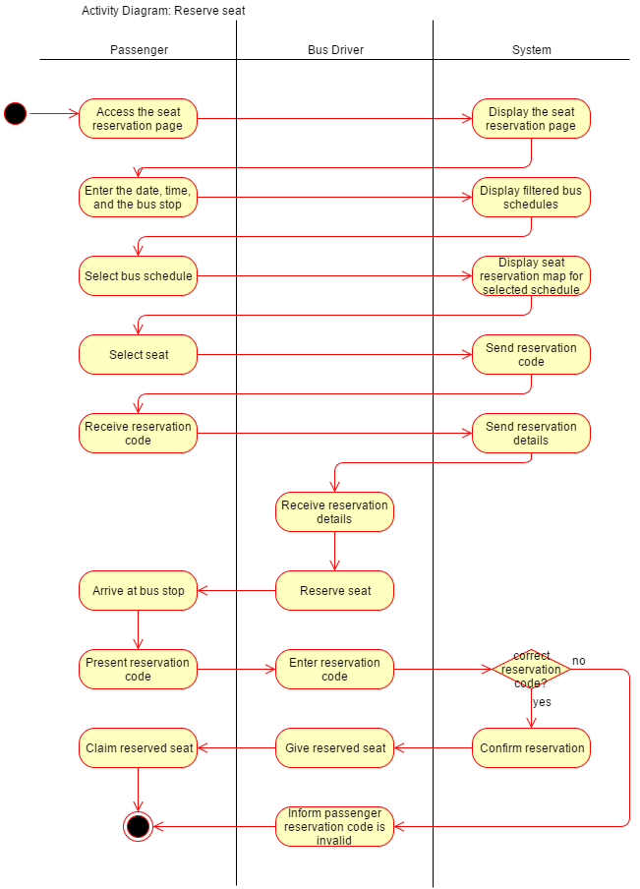

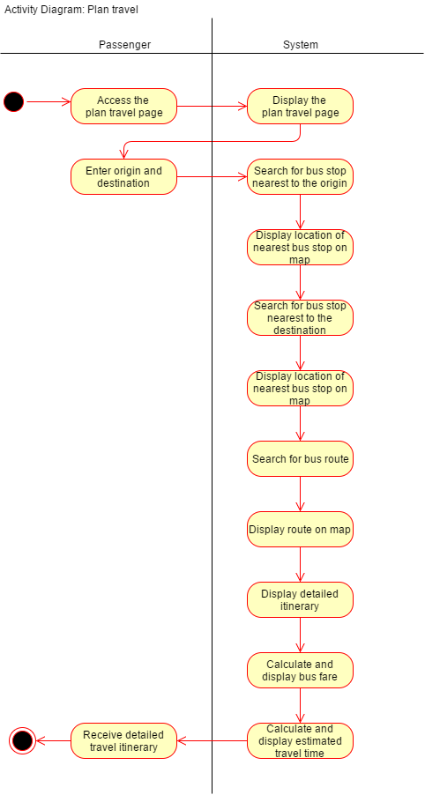

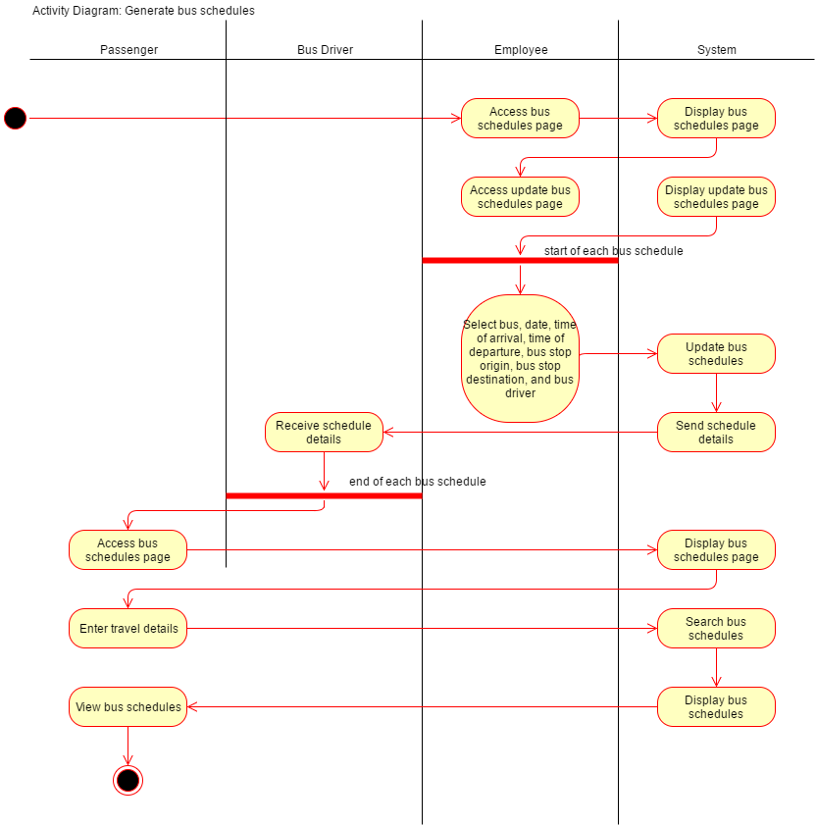

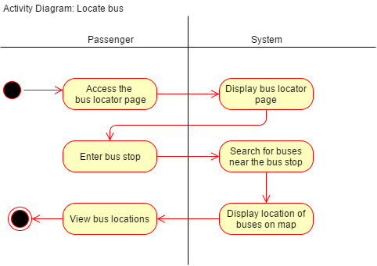

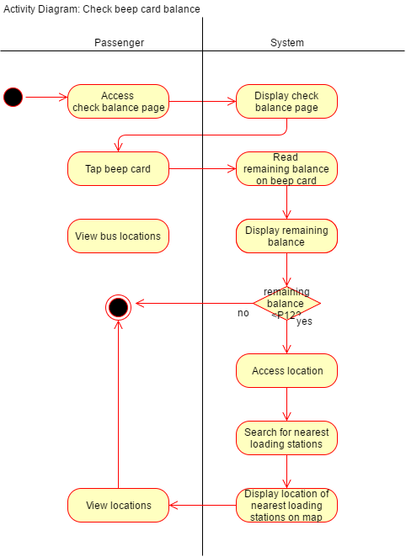

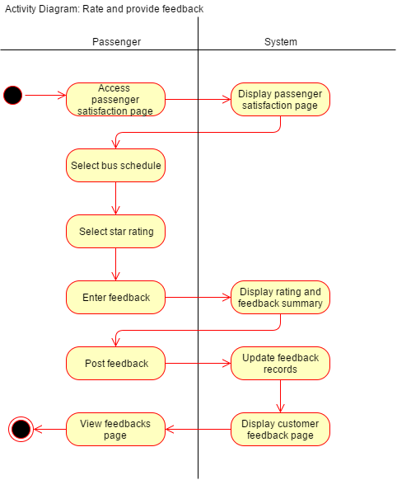

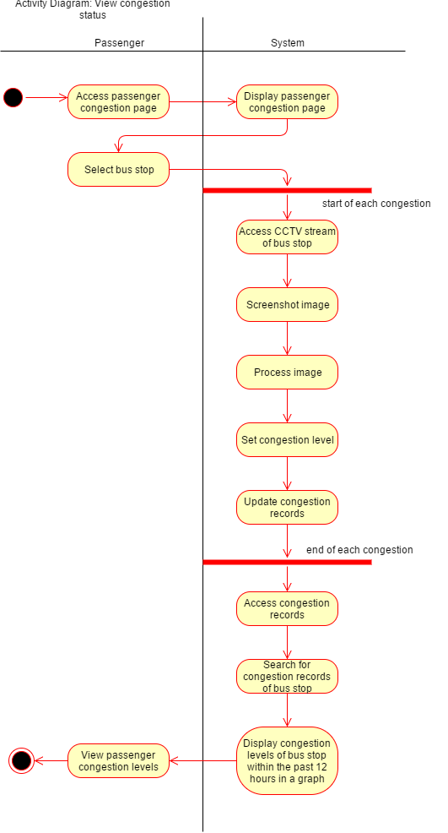

References

AF Payments, I. (2016). *FAQs*. Retrieved from beep™: https://www.beeptopay.com/faqs.html

AF Payments, Inc. (2016). *beep™ is now available at Bayad Center*. Retrieved from beep™ : https://www.beeptopay.com/news/beep-is-now-available-at-bayad-center/index.html

AF Payments, Inc. (2016). *beep™ is now available at FamilyMart*. Retrieved from beep™: https://www.beeptopay.com/news/beep-is-now-available-at-familymart/index.html

AF Payments, Inc. (2016). *Home*. Retrieved from beep™: https://www.beeptopay.com/home/index.html

*android.database.sqlite*. (n.d.). Retrieved from developer.android.com: https://developer.android.com/reference/android/database/sqlite/package-summary.html

*Global Positioning System (GPS)*. (2013). Retrieved from mocomi: http://mocomi.com/gps/

*History of Near FIeld Communications*. (2017). Retrieved from near field communication.

Obias, M. (2017, August 9). BGC Bus. (A. C. Alcaraz, S. M. Angot, J. V. Besmano, & J. G. Brioso, Interviewers)

Rouse, M. (2007, April). *RFID (radio frequency identification)*. Retrieved from internetofthingsagenda.techtarget.com: http://internetofthingsagenda.techtarget.com/definition/RFID-radio-frequency-identification

Rouse, M. (2010, June). *http://internetofthingsagenda.techtarget.com*. Retrieved from Internet of Things: http://internetofthingsagenda.techtarget.com/definition/RFID-tagging

Todd, A., & Barraclough, C. (2017, June 28). *What is Android OS*. Retrieved from recombu.com: https://recombu.com/mobile/article/what-is-android-and-what-is-an-android-phone_M12615.html#

# Appendix

## Letter of Request for Interview to the management of the BGC Bus



3 August 2017

MR. JAIME FRANCISCO T. GALVEZ, JR.

General Manager

Bonifacio Transport Corporation

Utility Area 31st Street

Crescent Park West Bonifacio Global City

DEAR MR. GALVEZ:

Greetings!

We are 3rd year students of Asia Pacific College, under the BS Computer Science program, specializing in Systems Software. We are currently enrolled in an Introduction to Systems Analysis and Design (INTSDEV) course that requires students to complete an industry-based project of developing systems or applications for a company, government agency, or institution.

Public transportation, particularly the BGC Bus, has been the interest of our group. We aim to learn more about the business process of the BGC Bus, and to identify issues and problems encountered by the management and the passengers of the BGC Bus, to be able to propose a suitable system or application that will help not only the management of the BGC Bus, but also its passengers.

In this light, we would like to request for an interview with you or your representative on August 9, 2017 between 2:00-5:00PM in your office. We have at least 20 questions and might take about 45 minutes of the interviewer’s time. Attached herewith is the list of interview questions.

If you have some inquiries or clarifications, or if you would like to set the interview on a different date and time, please feel free to get in touch with our project manager, Anna Lynn Alcaraz, at 09998845654, or through e-mail at acalcaraz@student.apc.edu.ph.

Thank you in advance.

Sincerely,

|  |  |  |  |
| --- | --- | --- | --- |
| ANNA LYNN C. ALCARAZ  Project Manager | SAMMY BOY M. ANGOT  Team Member | JUSTIN V. BESMANO  Team Member | JOB G. BRIOSO  Team Member |

Noted by:

|  |  |
| --- | --- |
| MS. RHEA-LUZ VALBUENA  Course Instructor | MR. JUSTIN DAVID PINEDA  Project Adviser |

## Questions for the Interview with the management of the BGC Bus



**Interview Questions: Bonifacio Transport Corporation**

1. What is the daily average total number of passengers of the BGC Bus?
2. How many passengers ride the BGC Bus in every month? If possible, please specify for each month of the year.
3. What are the different bus routes of the BGC Bus?
4. Which route caters to the most number of passengers? Which route caters to the least number of passengers?
5. For each bus route, what are the operating hours?
6. What are the peak hours and off-peak hours? If peak hours and off-peak hours vary for each bus route, please specify.
7. For each bus route, how many buses are deployed during peak hours, and during off-peak hours?
8. Are the buses of the BGC Bus equipped with GPS? If yes, may the group be allowed to use the GPS for our app or system?
9. Are the buses of the BGC Bus equipped with CCTV? If yes, may the group be allowed to use the CCTV for our app or system?
10. Is there a fixed schedule for bus arrival and bus departure?
11. Between each bus, what is the time interval during peak hours, and during off-peak hours?
12. What is the average waiting time of passengers during peak hours, and during off-peak hours?
13. How much is the bus fare for each bus route?
14. Which bus stops or terminals have loading stations and/or ticket booths?
15. Are the bus stops or terminals equipped with CCTV? If yes, may the group be allowed to use the CCTV for our app or system?
16. Can a new mode of payment, other than the beep™ card, be allowed?
17. What are the problems or difficulties encountered by the BGC Bus?
18. What are the strategies employed to accommodate additional passengers during peak hours?
19. How are announcements regarding the operations of the BGC Bus posted to the public?
20. What technology is used by the BGC Bus to predict the number of minutes until the arrival of the next bus?

## Interview Transcript

Interviewer: Anna Lynn C. Alcaraz, Sammy Boy M. Angot, Justin V. Besmano, Job G. Brioso

Interviewee: Mr. Mike Obias, Assistant Operation Manager, BGC Bus

Date: August 9, 2017

Time: 4:00 PM

Venue: Bonifacio Transport Corporation

Utility Area 31st Street

Crescent Park West, Bonifacio Global City

(start of interview)

Interviewer: What is the daily average total number of passengers of the BGC Bus? How many passengers ride the BGC Bus in every month?

Interviewee: Right now, we have 44,000 passengers on weekdays, and half of that on weekends. So, during Saturdays and Sundays, 20,000. In a month, we have almost 1,000,000 passengers.

Interviewer: Which months have the highest number of passengers, and which months have the lowest number of passengers?

Interviewee: Before, during March to June, we have less passengers, compared to the other months because those months are usually the students’ summer vacation; however, because some universities moved the start of their academic calendar, we noticed a decrease in passengers during July to September. But the month with the lowest ridership is March because it has lots of holidays, like Holy Week. Whenever there is a long holiday, we always have the lowest ridership.

Interviewer: What are the different bus routes of the BGC Bus?

Interviewee: Just last Monday, August 7, we recently implemented improved bus routes for the BGC Bus. We have 7 new regular routes that run from 6AM to 10PM. Then, we also have the augmentation, or what we call the extension routes. These extension routes travel to places outside BGC, like Ayala, we call it Ayala Route or Ayala Express. The second one is Arca South. It travels from here to Arca. Then the third one is the North Route, though the North Route still travels within BGC, but the North is handled by Megaworld, unlike BGC, which is handled by FBDC Ayala.

Interviewer: Which route caters to the most number of passengers? Which route caters to the least number of passengers?

Interviewee: So far, the route with the highest recorded number of passengers is the West Route. It is the combination of the Upper West and Lower West. Before it was just the West Route, but we split it into Upper and Lower. The West side of BGC Bus is here, where the office of the BGC Bus is located, and the East part is Market! Market! The route with the least number of passengers is the route going to Kalayaan. We recently implanted this route, just two months ago. It only runs for 4 hours in the morning on weekdays. Right now, it only has 100 pax.

Interviewer: For each bus route, how many buses are deployed for each route?

Interviewee: The amount of buses deployed to each route depends on the availability. But right now, our fleet is composed of 51 buses. The route with the most buses being deployed to is the one with the highest ridership, the West, followed by the East, then the other routes.

Interviewer: What is the capacity of the bus?

Interviewee: The buses have perimeter seating. In has a seating capacity of 37 passengers, but the bus can accommodate 75 passengers comfortably. The maximum capacity of the bus is 90 passengers.

Interviewer: What are the peak hours and off-peak hours?

Interviewee: Peak hours apply to all the routes. Peak hours are 6AM to 10AM and 4PM to 8PM.

Interviewer: Are the buses of the BGC Bus equipped with GPS? If yes, may the group be allowed to use the GPS for our app or system?

Interviewee: All buses are equipped with GPS.

Interviewer: Are the buses of the BGC Bus equipped with CCTV? If yes, may the group be allowed to use the CCTV for our app or system?

Interviewee: The buses are not yet equipped with CCTV, but we are planning to equip them. The challenge is for real-time streaming. The plan is to equip each bus with 4 CCTVs. But the challenge is with the bandwidth.

Interviewer: Are the bus stops or terminals equipped with CCTV? If yes, may the group be allowed to use the CCTV for our app or system?

Interviewee: The terminals are equipped with CCTVs but some of the stops don’t. But aside from the CCTV of the BGC Bus, we also have the city CCTVs. These stops are within range of the city CCTVS.

Interviewer: Is there a fixed schedule for bus arrival and bus departure?

Interviewee: We have a fixed schedule.

Interviewer: Between each bus, what is the time interval during peak hours, and during off-peak hours? What is the average waiting time of passengers during peak hours, and during off-peak hours?

Interview: The standard waiting time is 10 minutes. Every passenger should only wait, at most, for 10 minutes. That’s our goal here. For the actual, it varies depending on the traffic, the speed of the bus.

Interviewer: How much is the bus fare for each bus route?

Interviewee: We have a fixed fare price of P12 for all routes, except for Arca South and Nuvali, but that’s because they’re extension routes.

Interviewer: Which bus stops or terminals have loading stations and/or ticket booths?

Interviewee: Only selected stops have ticket booths. We encourage the passengers to use the beep™ cards. However, for stops near government offices, we have to deploy ticket sellers. These government offices have visitors that do not regularly travel within BGC. We cannot insist they buy their own beep™ cards. Stops with ticket sellers are Bonifacio Stopover, RCBC, Nutriasia, BGC Bus Bonifacio One Technology Tower terminal, BGC Bus Ayala terminal, and BGC Bus Market! Market! terminal. beep™ cards can be reloaded at the terminals.

Interviewer: What are the problems or difficulties encountered by the BGC Bus?

Interview: Passenger complaints.

(end of interview)

## Survey Questionnaire

Good day!

We are 3rd year students of Asia Pacific College, under the BS Computer Science program, specializing in Systems Software. For our Introduction to Systems Analysis and Design (INTSDEV) course this term, our group has to conduct a survey on passengers of the BGC Bus, as part of our data gathering for our project.

We would like to ask you to answer the following questions.

Thank you for your cooperation.

____________________________________________________________________________

Survey Questions:

1. Why do you ride the BGC Bus? (check all that apply)

☐ to go to school

☐ to go to work

☐ to go home

☐ to go to the mall

☐ others, please specify: ____________________

1. How often do you ride the BGC Bus in a week? (check one only)

⚪️ I don't regularly ride the BGC Bus

⚪️ 1-5 times a week

⚪️ 6-10 times a week

⚪️ 11-15 times a week

⚪️ more than 15 times a week

1. What are the problems you encounter when riding the BGC Bus? (check all that apply)

☐ long queue when buying bus ticket or loading beep™ card

☐ long queue when waiting for the bus

☐ inaccurate bus schedules

☐ congestion of passengers inside the bus

☐ others, please specify: ____________________

1. How do you pay for the BGC Bus fare? (check all that apply)

☐ bus ticket

☐ beep™ card

1. If you buy tickets, how many minutes do you usually take to buy bus tickets? (check one only)

⚪️ less than a minute

⚪️ 1-2 minutes

⚪️ 3-4 minutes

⚪️ 5 minutes or more

1. If you use the beep™ card, where do you load your beep™ card? (check all that apply)

☐ LRT stations

☐ MRT stations

☐ BGC Bus Ayala terminal

☐ BGC Bus Market! Market! terminal

☐ BGC Bus Bonifacio One Technology Tower terminal

☐ FamilyMart

☐ Circle K

☐ SM malls

1. How many minutes do you usually have to wait before boarding the bus? (check one only)

⚪️ 1-5 minutes

⚪️ 6-10 minutes

⚪️ 11-15 minutes

⚪️ 16-20 minutes

⚪️ 21-25 minutes

⚪️ 25-30 minutes

⚪️ more than 30 minutes

1. Will an app for the BGC Bus be useful to you? (check one only)

⚪️ yes

⚪️ no

1. What features of a BGC Bus app will be useful to you? (check all that apply)

☐ the app can give users step-by-step directions from origin to direction, with estimated travel time and fare

☐ the app can display a map indicating all bus routes, including stops and nearby landmarks for each bus route

☐ the app can display nearby locations of beep™ card loading stations on the map

☐ the app can display bus arrival times and departure times

☐ the app can display how many minutes until the next bus arrives at the bus stop

☐ the app can show the real-time location of the buses on the map

☐ users can check how long the lines are at each bus stop

☐ users can check the remaining balance on their beep™ card

☐ users can use their cellphone load to pay for the bus fare

## Other results of the survey conducted by the group on BGC Bus passengers

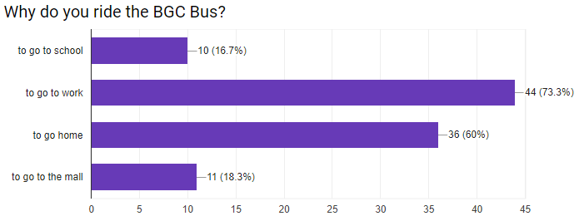

Figure 21. Results of the survey conducted by the group on BGC Bus passengers:

Why do you ride the BGC Bus?

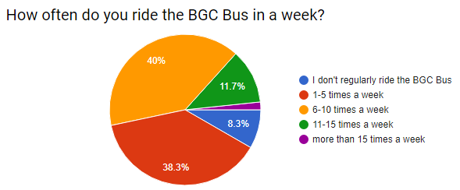

Figure 22. Results of the survey conducted by the group on BGC Bus passengers:

How often do you ride the BGC Bus?

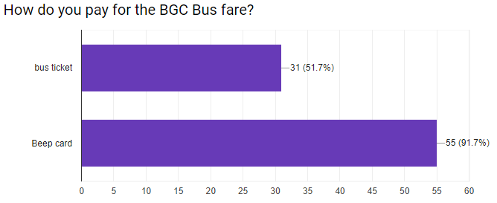

Figure 23. Results of the survey conducted by the group on BGC Bus passengers:

How do you pay for the BGC Bus fare?